E-Commerce Sales Performance Analysis
Course: MBAG 20 - Business Analytics
Student Name: Advitiya Saksena
Roll No:25030302005

1. Introduction and Data Overview
This report presents a comprehensive analysis of transactional data from an Indian fashion e-commerce platform. The dataset (db.csv) comprises 31,047 orders, capturing customer demographics, product attributes, sales channels, and logistics variables.
The objective is to derive actionable insights through exploratory data analysis (EDA), scenario-based What-If modeling, and So-What interpretation for managerial decision-making.
Key Variables Analyzed
- Gender (M/W)
- Age
- Sales Channel (Amazon, Myntra, Flipkart, etc.)
- Product Category (Set, Kurta, Western Dress, Saree, Top, etc.)
- Quantity (Qty)
- Revenue (Amount in ₹)
- Shipping State (ship-state)
- Order Status
Data Preparation and Cleaning (R)
The dataset was pre-processed to ensure analytical consistency:
- Standardized categorical variables (e.g., Gender recoded to “M” and “W”)
- Normalized category labels (converted to lowercase)
- Converted quantity values from text to numeric format
- Ensured correct data types for Age and Revenue
- Created age group segments:
(0–18, 19–25, 26–35, 36–45, 46–55, 56–65, 65+)

2. Exploratory Data Analysis and Visualization
The EDA phase identifies core revenue drivers and customer behavior patterns.
Revenue by Gender
Female customers account for a significantly higher share of total revenue, indicating a strong gender skew in purchasing behavior.
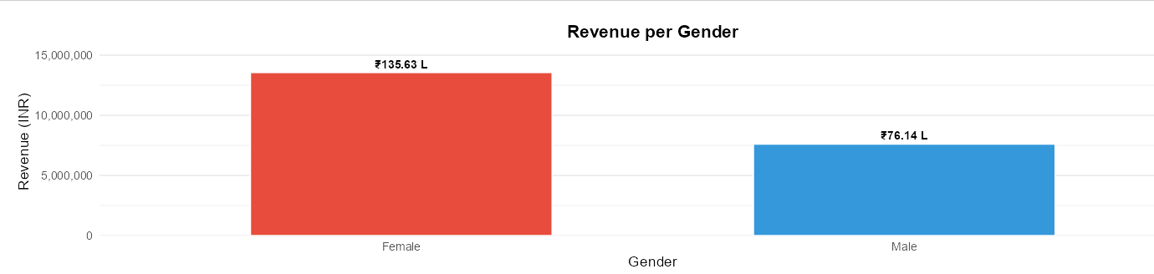
Top States by Revenue
Revenue concentration is highest in:
- Maharashtra
- Karnataka
- Tamil Nadu
- Delhi
- Uttar Pradesh
This highlights regional demand concentration in economically active states.
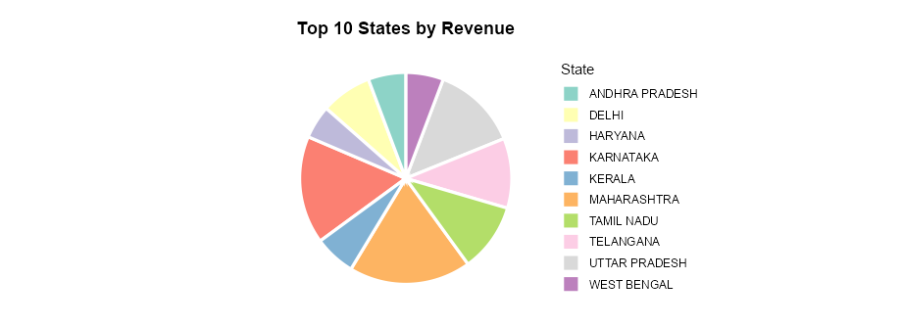
Revenue by Product Category
“Set” and “Kurta” categories dominate revenue contribution, indicating strong product-market fit.
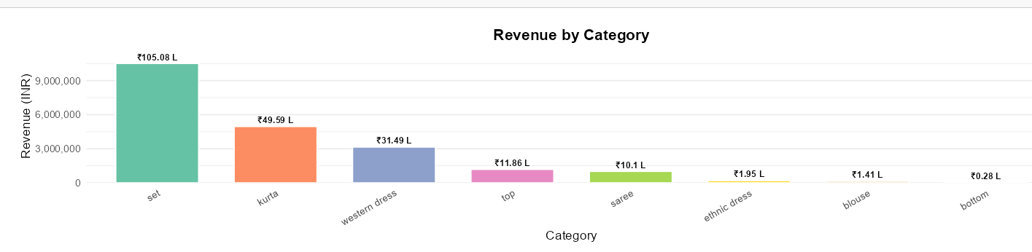

Channel Contribution Analysis
Amazon emerges as the primary revenue driver, followed by Myntra and Flipkart.
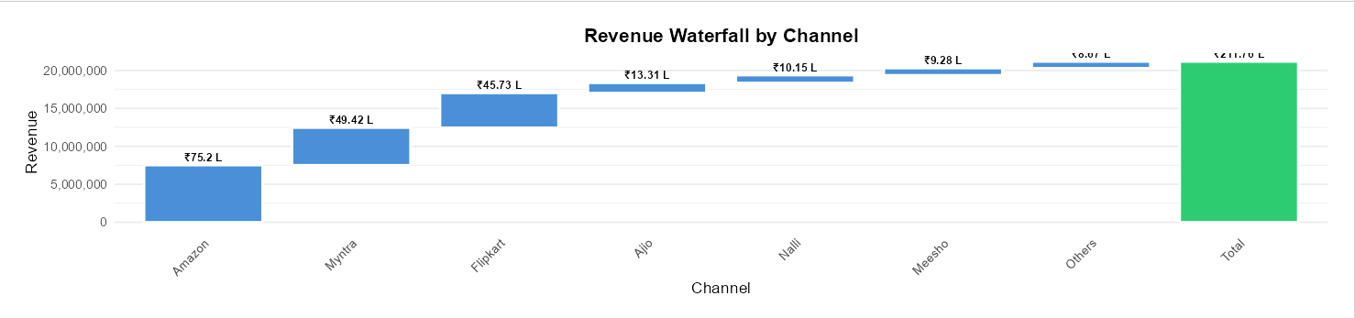
Customer Distribution by Age Group
The 26–35 and 36–45 segments represent the highest order volumes, forming the core customer base.
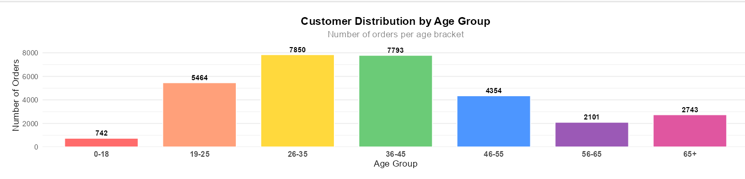

3. What-If Analysis (Scenario-Based Modeling)
Scenario analysis was conducted to evaluate potential revenue impact under strategic interventions.
Baseline Revenue
₹2,85,47,312

Scenario A: 10% Increase in Amazon Sales
- New Revenue: ₹2,98,14,892
- Incremental Gain: ₹12,67,580
- Growth: +4.44%
Interpretation: Marginal improvements in Amazon performance yield significant revenue impact due to platform dominance.

Scenario B: 15% Increase in Maharashtra Sales
- New Revenue: ₹2,94,38,671
- Incremental Gain: ₹8,91,359
- Growth: +3.12%
Interpretation: Geographic concentration enables efficient, targeted revenue expansion.

Scenario C: Kurta Promotion Strategy
- Price Discount: 15%
- Volume Increase: 35%
- Net Multiplier: 1.1475
- New Revenue: ₹2,97,65,418
- Incremental Gain: ₹12,18,106
- Growth: +4.27%
Interpretation: Elastic demand in key categories can drive net-positive revenue despite discounting.

Combined Scenario Impact
- New Revenue: ₹3,19,84,567
- Total Uplift: ₹34,37,255
- Overall Growth: +12.04%
Insight: Simultaneous optimization across channel, geography, and category delivers compounding gains.

4. So-What Analysis (Strategic Interpretation)
Key Insight 1: Revenue is Female-Dominated (~68%)
Implication:
The business is structurally dependent on female consumers. Strategic focus should remain on:
- Women-centric product lines
- Personalized marketing campaigns
- Occasion-based collections

Key Insight 2: High Dependence on Amazon
Implication:
Platform concentration introduces operational risk:
- Vulnerability to commission changes
- Algorithm dependency
- Limited pricing control
Diversification is not optional—it is a strategic necessity.

Key Insight 3: Category–Age–Region Alignment
“Set” and “Kurta” categories perform strongly among women aged 26–45 in top states.
Implication:
This is the core revenue engine. Any targeted intervention here yields disproportionate returns.

Critical Drivers Identified
- Primary Drivers: Channel, Category, Geography
- Key Risk: Over-reliance on Amazon and Maharashtra
- Primary Opportunity: Focused category promotions in high-performing segments

5. Visualization-Driven Storytelling
The analytical visuals collectively present a coherent business narrative:
- Gender & Category Charts: Define who buys and what sells
- Channel Waterfall: Reveals revenue concentration risk
- Age Distribution: Identifies core customer segments
Most Impactful Visualization
The Revenue Waterfall by Channel provides the clearest strategic insight by quantifying platform dependency and guiding scenario modeling.

6. Strategic Recommendations
Recommendation 1: Category-Focused Campaign
Insight: Kurtas/Sets dominate revenue among women
Action:
Launch a “Women’s Kurta & Set Festival”
- 15% discount
- Target: Women aged 26–45
- Platforms: Amazon + Myntra
Expected Impact: ~₹12 lakh incremental revenue

Recommendation 2: Geo-Targeted Expansion
Insight: Maharashtra and Karnataka lead revenue
Action:
- Run localized digital campaigns
- Offer region-specific promotions
Expected Impact: ₹8–10 lakh incremental revenue

Recommendation 3: Channel Diversification Strategy
Insight: Over-dependence on Amazon
Action:
- Introduce exclusive SKUs on Myntra and Meesho
- Negotiate platform commissions
- Strengthen multi-channel presence
Expected Outcome: Reduced concentration risk and improved margin stability

